TTVG Web Site

Version: 1.0.0

Date: July 16, 2017

Change History

|  |  |  |
| --- | --- | --- |
| Version | Changes | Date |
| 1.0.0 | Initial Version | July 17, 2017 |
|  |  |  |
|  |  |  |
|  |  |  |

Contents

1 System Prerequisites 4

1.1 Java 4

1.2 Web Server 4

1.3 Database 4

1.4 Database Client 4

1.5 Eclipse 4

2 Database Implementation 5

2.1 Database 5

2.1.1 Creation 5

2.1.2 Deletion 5

2.2 Tables 5

2.2.1 Creation 5

2.2.2 Drop 5

2.3 Backup & Restore 5

2.3.1 Export 5

2.3.2 Import 5

3 User Roles 6

3.1 Guest User 6

3.2 Registered User 6

3.3 Topic Admin Role 6

3.4 Administrator 6

4 Home & Entry Page 7

4.1 Title Area 7

4.2 Side Menu of Functions 7

4.3 Content Panel 7

4.4 Footnote 7

5 Home & Bulletin 8

6 Forums 9

7 Events 10

7.1 Display 10

7.2 Calendar 10

7.3 Registry 10

7.4 Management 10

8 My Profile 11

9 Audit 12

10 Contacts and About 13

11 Open Topics 14

11.1 Topic Admin Role 14

11.2 Payment Record 14

# System Prerequisites

## Java

Version: jdk-7u40-windows-x64.exe

Installation: Run from Command Line

Environment Variables: JDK_HOME=E:\Java\jdk1.7.0_40-64

JAVA_HOME=%JDK_HOME%

JRE_HOME=%JAVA_HOME%\jre

## Web Server

Version: apache-tomcat-8.5.13-windows-x64.zip

Installation: Unzip to E:\Java

Startup: E:\Java\apache-tomcat-8.5.13\bin\startup.bat

## Database

Version: mysql-5.6.14-win32.zip

Installation: Unzip to E:\Java

Startup: E:\Java\mysql-5.6.14-win32\bin\mysqld.exe

## Database Client

Version: mysql-workbench-community-6.0.7-win32-noinstall.zip

Installation: Unzip to E:\Java

Startup: E:\Java\MySQL Workbench 6.0.7 CE\MySQLWorkbench.exe

Reset the root password: From Management->Users and Privileges

Limit the client connections: Only from localhost

## Eclipse

Version: eclipse-standard-luna-M2-win32.zip

Installation: Unzip to E:\Java

Workspace: E:\Jenny\GitHub\Projects\TTVG-JSP

# Database Implementation

## Database

The database is named TTVG in the MySQL server.

### Creation

* From “MySql WorkBench”,
* Right-clicking from Schemas,
* Select “Create Schema”
* Create database “TTVG”

### Deletion

* From “MySql WorkBench”,
* Right-clicking the database schema “TTVG”,
* Select “Drop Schema”
* Confirm to delete this database

## Tables

Run scripts to install/drop tables for the TTVG database.

### Creation

Run the script: E:\Jenny\GitHub\Projects\TTVG-JSP\Database\db_tables_install.bat

### Drop

Run the script: E:\Jenny\GitHub\Projects\TTVG-JSP\Database\db_tables_drop.bat

## Backup & Restore

Run scripts to export/import tables for the TTVG database.

### Export

Run the script: E:\Jenny\GitHub\Projects\TTVG-JSP\Database\db_export.bat

### Import

Run the script: E:\Jenny\GitHub\Projects\TTVG-JSP\Database\db_import.bat

# User Roles

Four types of roles are defined to control the resource access.

## Guest User

This type of user has the general access to the basic content.

## Registered User

This type of user has to login into the application, and could have privileged access to such event register.

## Topic Administrator

May need a topic administrator for the forums, and events

## Administrator

The administrator has the power to and system administration, such as audit.

# Home & Entry Page

A single home page is designed in a framework in embed all functions

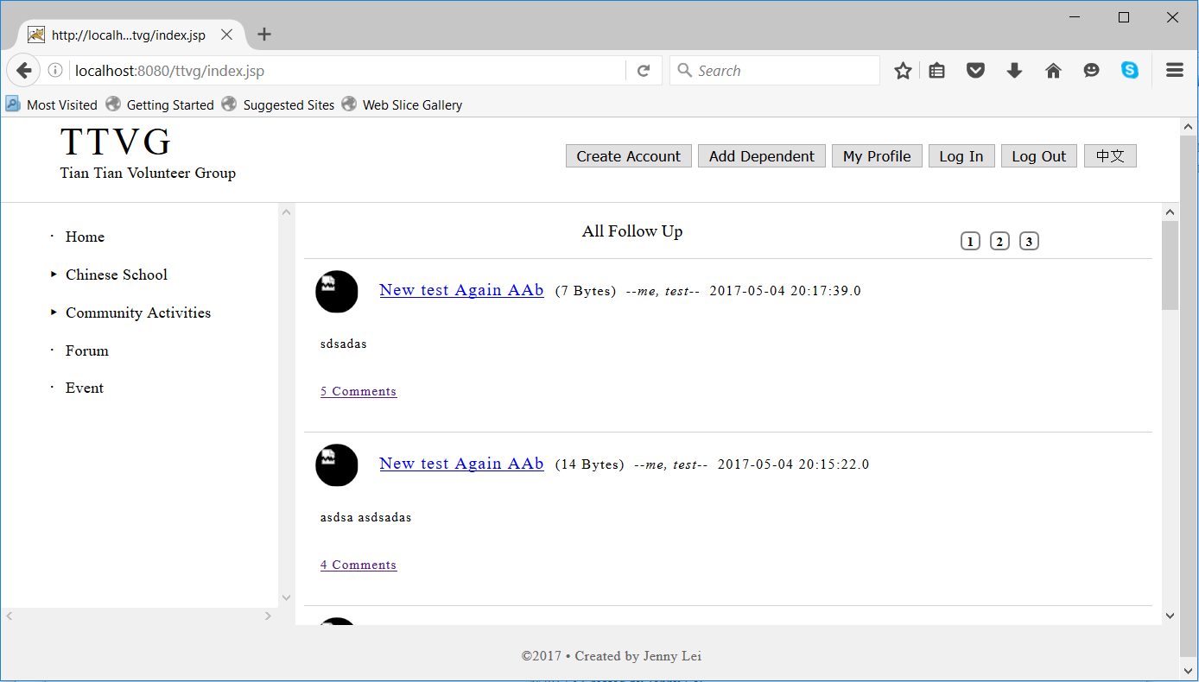

## Title Area

It displays the title information for TTVG (Tian Tian Volunteer Group).

On the right side of the title, user could login and select the language preference.

## Side Menu of Functions

The detail of each function is elaborated in the following sections

## Content Panel

It displays the main content.

Any error message is displayed at the top of the content, in red.

## Footnote

It displays the copyright and author information

# Home & Bulletin

## Display

## Create/Modify/Delete Bulletin

[Login] Topic Administrator

# Forums

## Display

## Add Follow-up

[Login] Registered User

## Delete Follow-up

[Login] Topic Administrator

## Create/Delete Topic

[Login] Administrator

# Events

## Display

## Calendar

## Registry

[Login] Registered User

## Management

[Login] Topic Administrator

Add/Modify/Remove

# My Profile

[Login] Registered User

## Account Creation

Create an account

## Dependent Creation

Create dependent account

## Register/Un-register Event

Register to an event for self or dependent.

# Audit

[Login] Topic Administrator

The critic operations are logged into an Audit table, include

* User registration
* Event creation/deletion, registration/un-registration

Information stored,

* Target, such as User, Event, Bulletin
* Content
* Action, such as Add, Modify, Remove

# Contacts and About

Static pages

# Open Topics

## Payment Record

No in the scope